Create new fact view
The next view we will create will be the new.html view. This template will contain a form that can be used to submit new Facts.
In the views folder, we will create a new template file called new.html:
1 | touch views/new.html
In the first part of this tutorial series, we added a route to POST new facts to the API. We now need to add a route that will GET the “new fact” template.
1  2  3  4  5  6  7  8  9  10  11  12  13 | package main  import (  "github.com/divrhino/divrhino-trivia/handlers"  "github.com/gofiber/fiber/v2"  )  func setupRoutes(app *fiber.App) {  app.Get("/", handlers.ListFacts)  app.Get("/fact", handlers.NewFactView) // Add new route for new view  app.Post("/fact", handlers.CreateFact)  }
The handlers.NewFactView function doesn’t exist yet, so let’s head into the handlers/facts.go file to create it. For now, we will just add a Title and a Subtitle, we will build on it later.
1  2  3  4  5  6  7  8  9  10  11  12  13  14  15  16  17  18  19  20  21  22  23  24  25  26  27  28  29  30  31  32  33  34  35  36  37  38  39 | package handlers  import (  "github.com/divrhino/divrhino-trivia/database"  "github.com/divrhino/divrhino-trivia/models"  "github.com/gofiber/fiber/v2"  )  func ListFacts(c *fiber.Ctx) error {  facts := []models.Fact{}  database.DB.Db.Find(&facts)  return c.Render("index", fiber.Map{  "Title": "Div Rhino Trivia Time",  "Subtitle": "Facts for funtimes with friends!",  "Facts": facts,  })  }  // Create new Fact View handler  func NewFactView(c *fiber.Ctx) error {  return c.Render("new", fiber.Map{  "Title": "New Fact",  "Subtitle": "Add a cool fact!",  })  }  func CreateFact(c *fiber.Ctx) error {  fact := new(models.Fact)  if err := c.BodyParser(fact); err != nil {  return c.Status(fiber.StatusInternalServerError).JSON(fiber.Map{  "message": err.Error(),  })  }  database.DB.Db.Create(&fact)  return c.Status(200).JSON(fact)  }
We can test out this new template by visiting http://localhost:3000/fact in the browser.
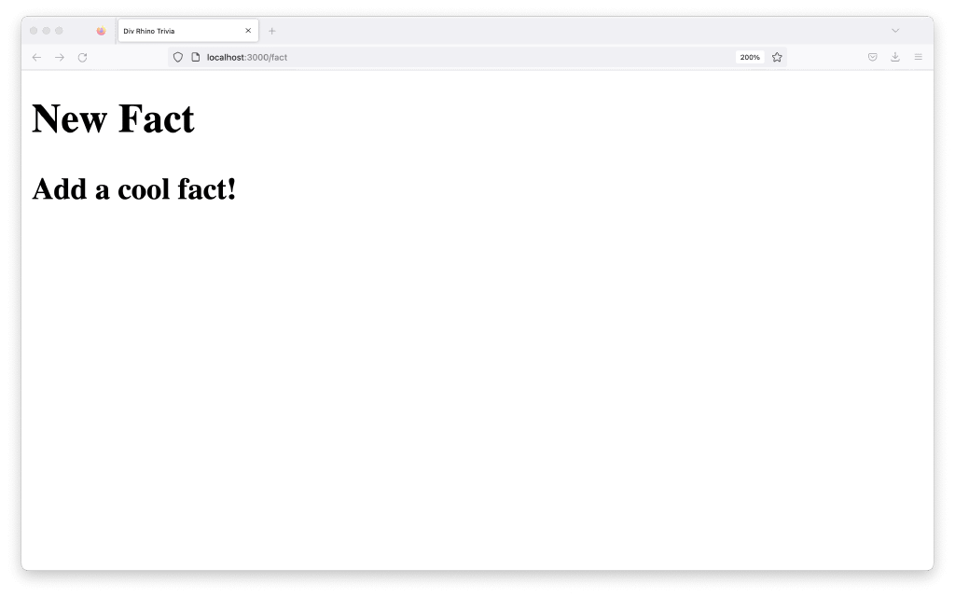
At the moment, we only have the default content from the main layout rendering on the page because our new.html file is empty. We will work on creating our form in the next step.
Use a form to create new facts
Back in our new.html view, we will write some markup for our new form:
1  2  3  4  5  6  7  8  9  10  11  12  13 | <form id="new-form" method="POST" action="/fact">  <label for="question">  <span>Question</span>  <input id="question" type="text" name="question">  </label>  <label for="answer">  <span>Answer</span>  <input id="answer" type="text" name="answer">  </label>  <input type="submit" value="Submit">  </form>
Without adding anything more, we can already submit this form data. However, when we do submit a new fact, the UX of it is a little awkward, as it redirects to the JSON response (in Firefox, anyway). We can fix that by redirecting to a success or confirmation page.
